**CLASS WORK PROGRAMMS**

**1.** Write a program to enter the marks of a student in four subjects. Then calculate the total and aggregate, display the grade obtained by the student. If the student scores an aggregate greater than 75%, then the grade is Distinction. If aggregate is 60>= and <75, then the grade is First Division. If aggregate is 50 >= and <60, then the grade is Second Division. If aggregate is 40>= and <50, then the grade is Third Division. Else the grade is Fail.

Sample Input & Output:

Enter the marks in python: 90

Enter the marks in c programming: 91

Enter the marks in Mathematics: 92

Enter the marks in Physics: 93

Total= 366

Aggregate = 91.5

DISTINCTION

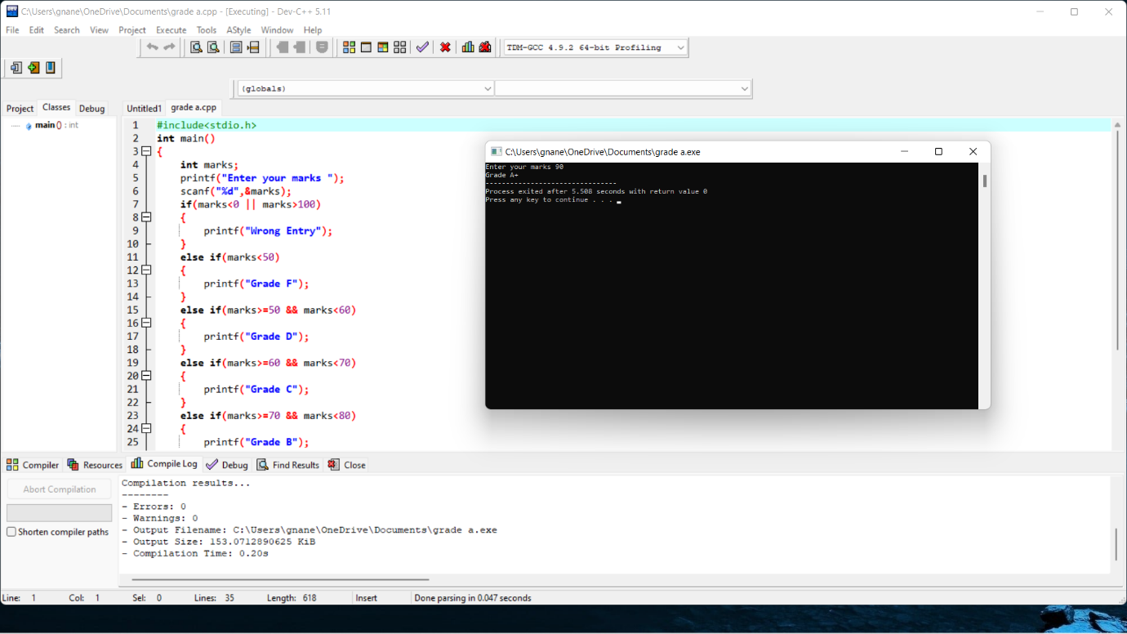

2.Mr. Johnson would like to know how many As, Bs, Cs, Ds, and Fs his students received on a test. He has n students who took the test. He would like to enter the student number and the number grade for the test for each student using structure. Develop the solution to print out each student’s student number, number grade and the total number of As, Bs, Cs, Ds, and Fs. His grading scale is as follows: 90–100 is an A, 78–89 is a B, 65– 77 is a C, 50–64 is a D, and below 50 is an F.

Sample Input :

Enter No.Students: 1

Enter student 1 Number , Grade : 2001, A

Sample Output:

Student 1 details:

Number : 2001

Grade : A

Total no. A: 1, B:0, c=0, D=0, F=0,

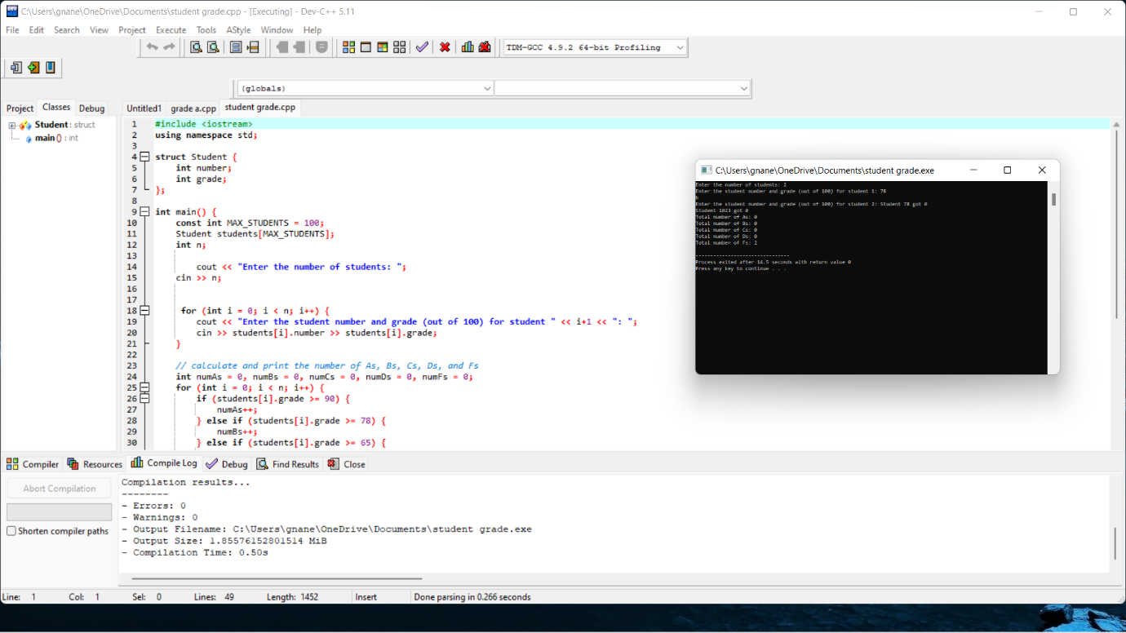

2.Write a program to print n prime numbers then find the nth Prime number

Sample Input:

N = 3

Sample Output:

3rd Prime number is 5

3 prime numbers after 5 are: 7, 11, 13

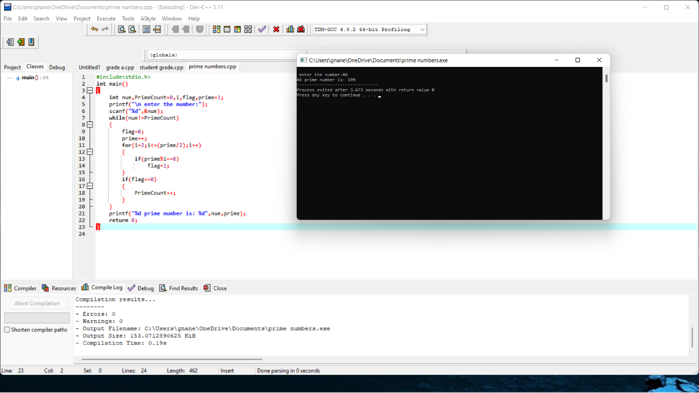

2.Write a c program to modify the constant variable in c.?

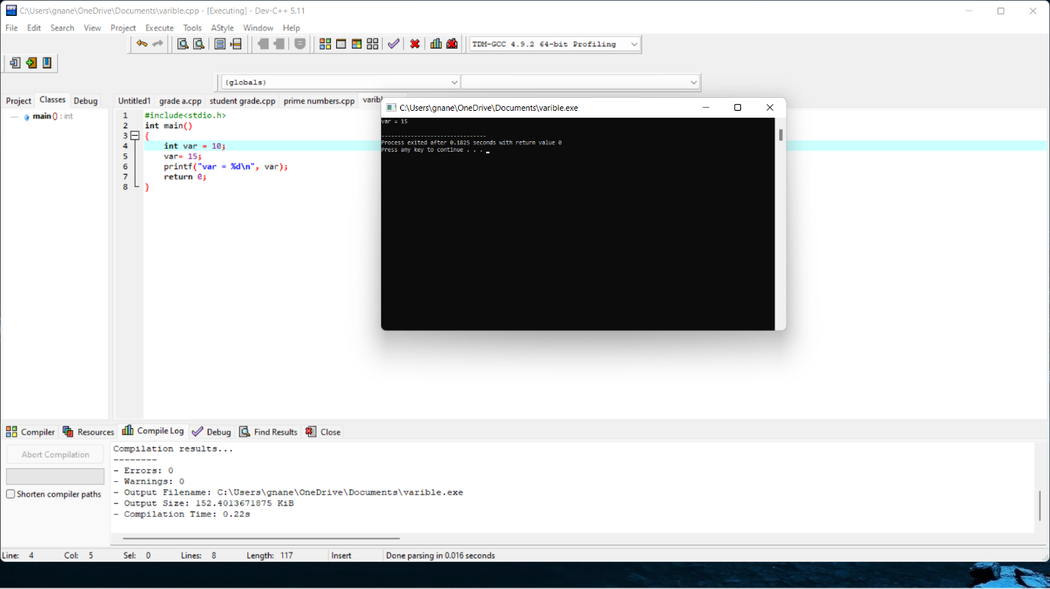

1. What will be output if you will execute following code?

char * call(int *,float *);

int main(){

char *string;

int a=2;

float b=2.0l;

char *(*ptr)(int*,float *);

ptr=&call;

string=(*ptr)(&a,&b);

printf("%s",string);

return 0;

}

char *call(int *i,float *j){

static char *str="c-pointer.blogspot.com";

str=str+*i+(int)(*j);

return str;

}

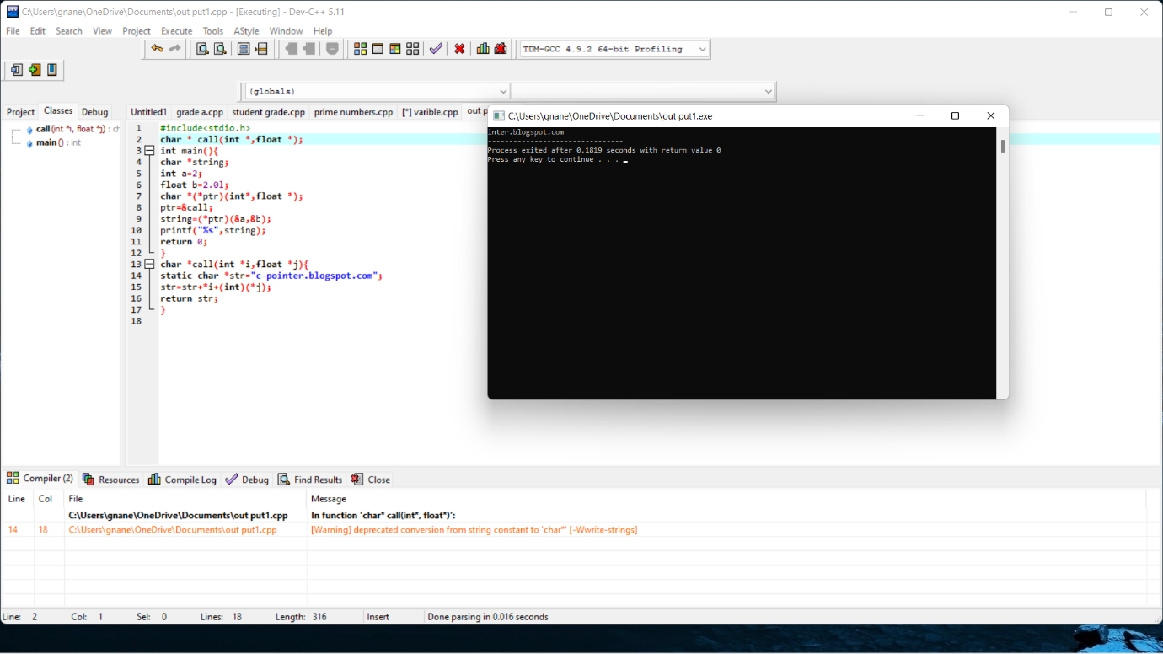

1. What will be the output of following c program?

#include "stdio.h"

int main(){

int i;

static int count;

for(i=NULL;i<=5;){

count++;

i+=2;

}

printf("%d",count);

}

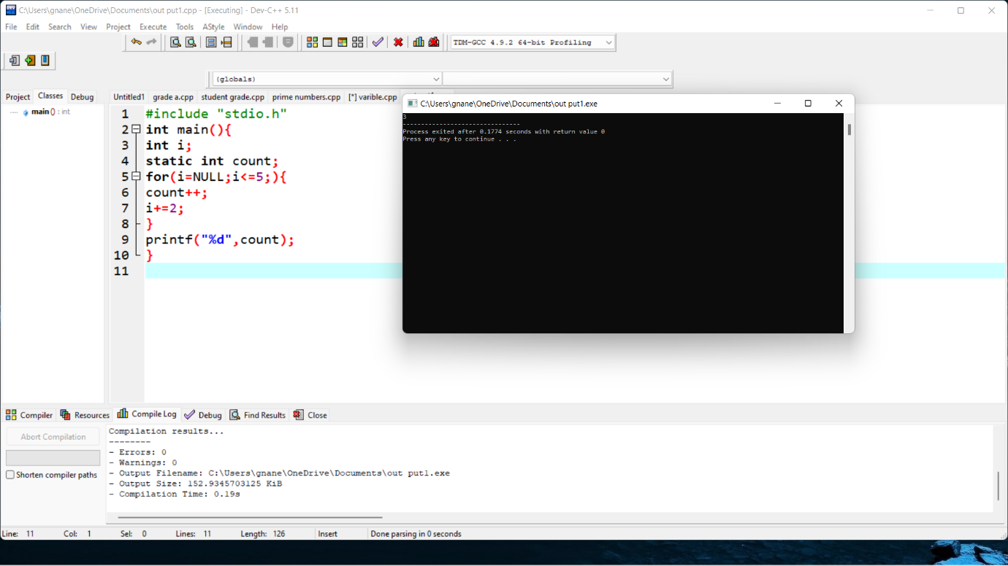

1. Write a program to guessing a number by the user against computer generated one using do while loop

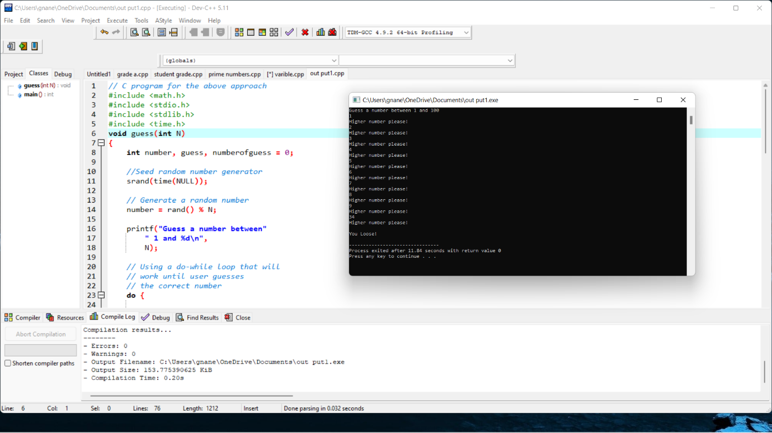

1. To write a C code to implement a function to compute power of a value

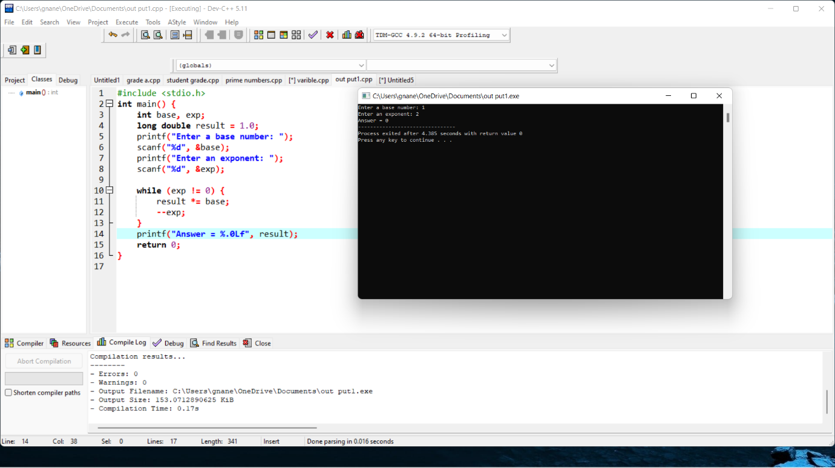

1. To write a C code to implement Nested Structure concept

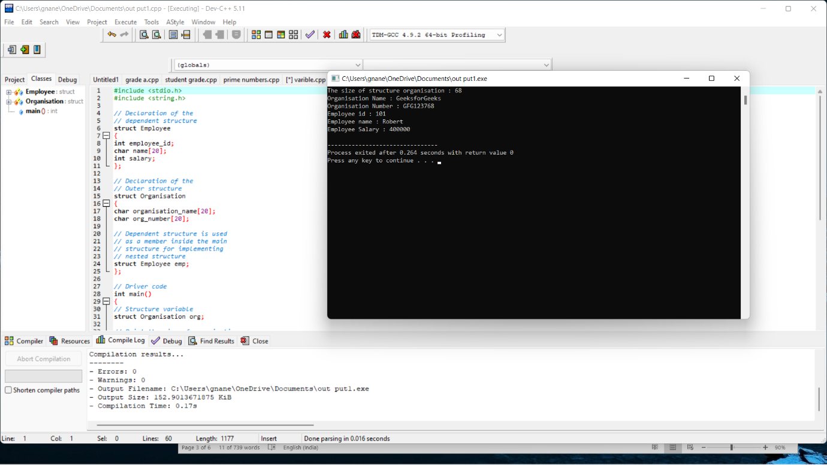

1. Program to add two numbers using Function with no arguments and no return value

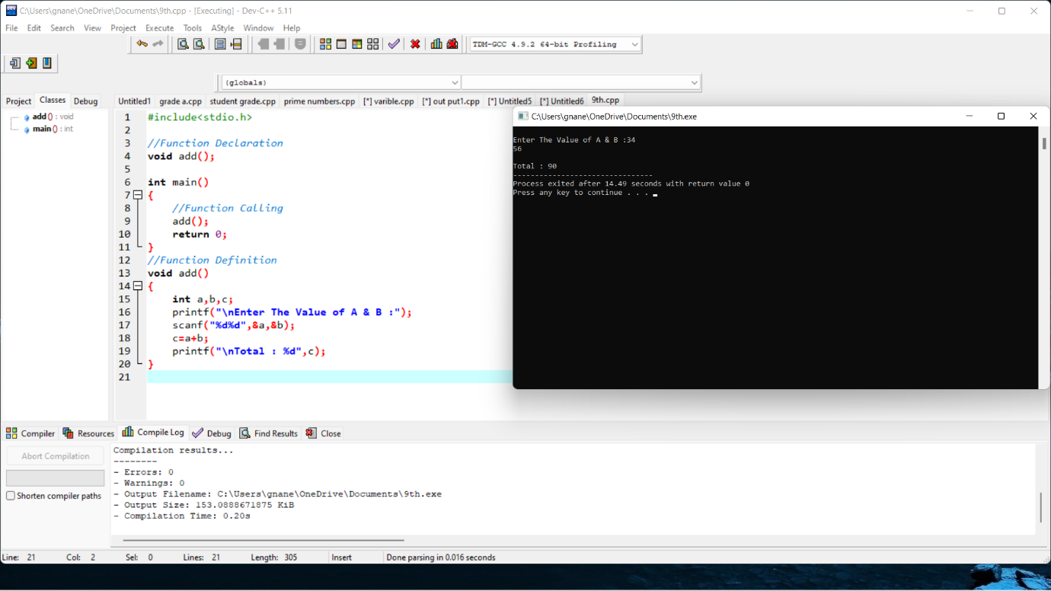

1. Program to add two numbers using Function with arguments and with return value
2. Program to swap two numbers using call by value
3. Find out the error and show the output

main()

{

int i=1,sum=0;

clrscr();

printf(“Enter the values for n:”);

scanf(“%d”,n);

while(i<=n)

{

sum==sum+i;

i++;

}

printf(“The sum of n numbers is”,sum);

}

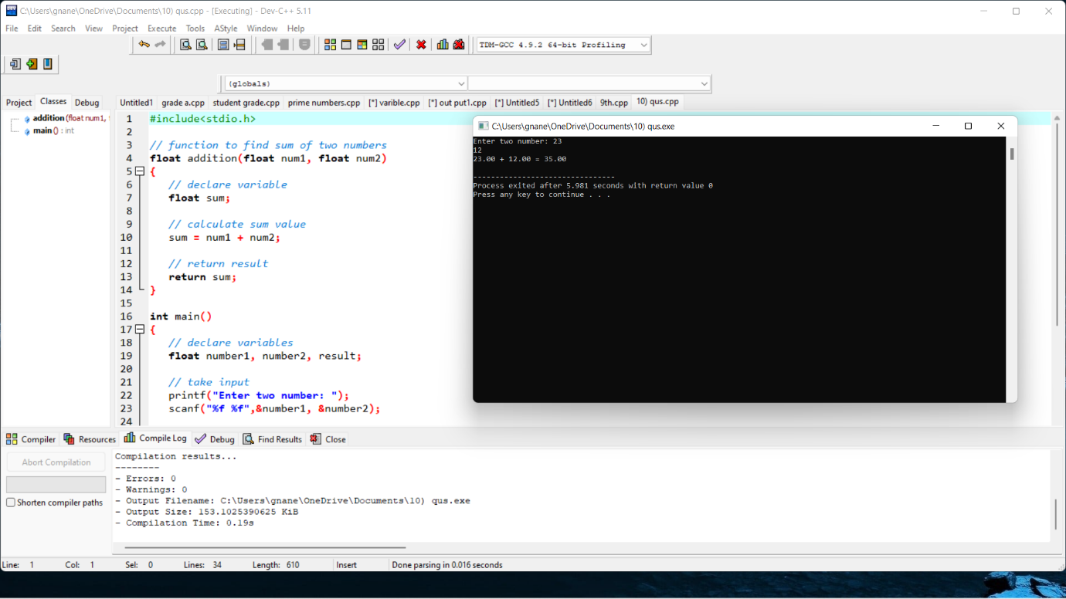

1. Program to swap two numbers using call by reference

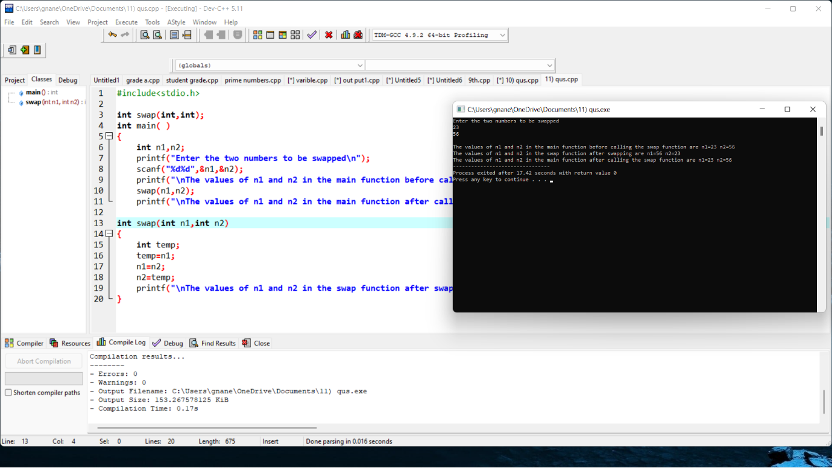

1. Write a program for Binary Search using recursive functions

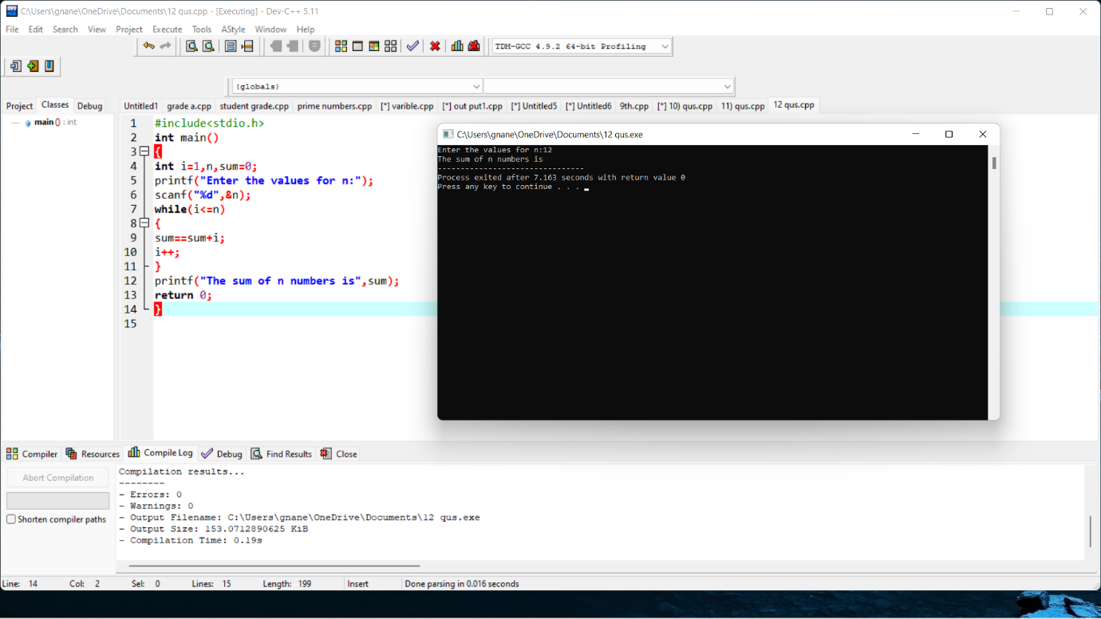

1. Program to find Employee no, name, salary, doj using nested structure

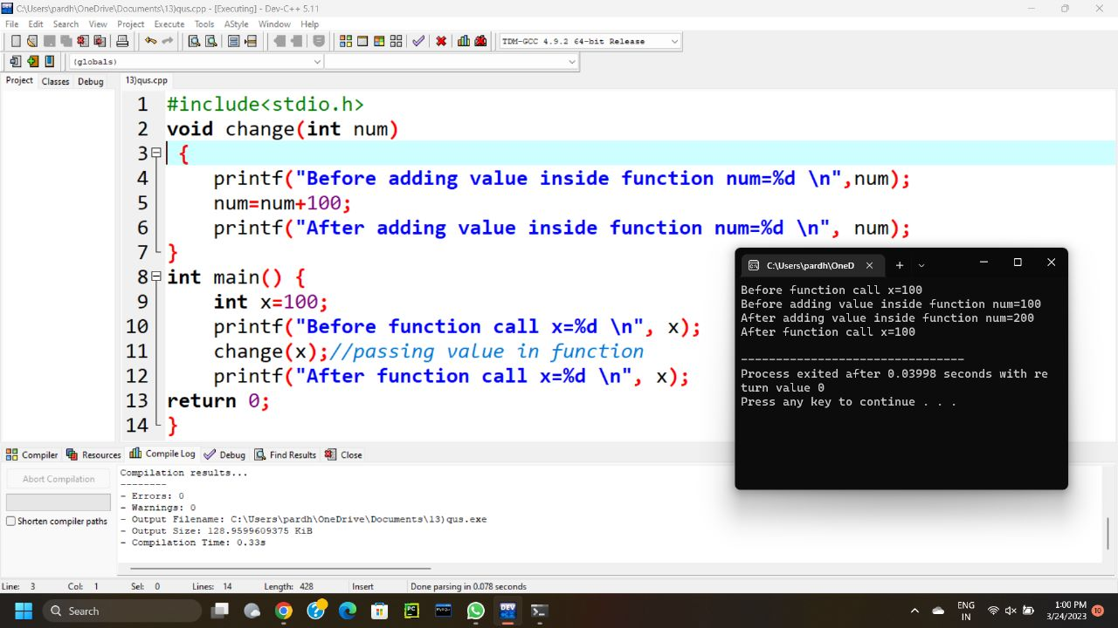

1. Program to find student details using nested structure

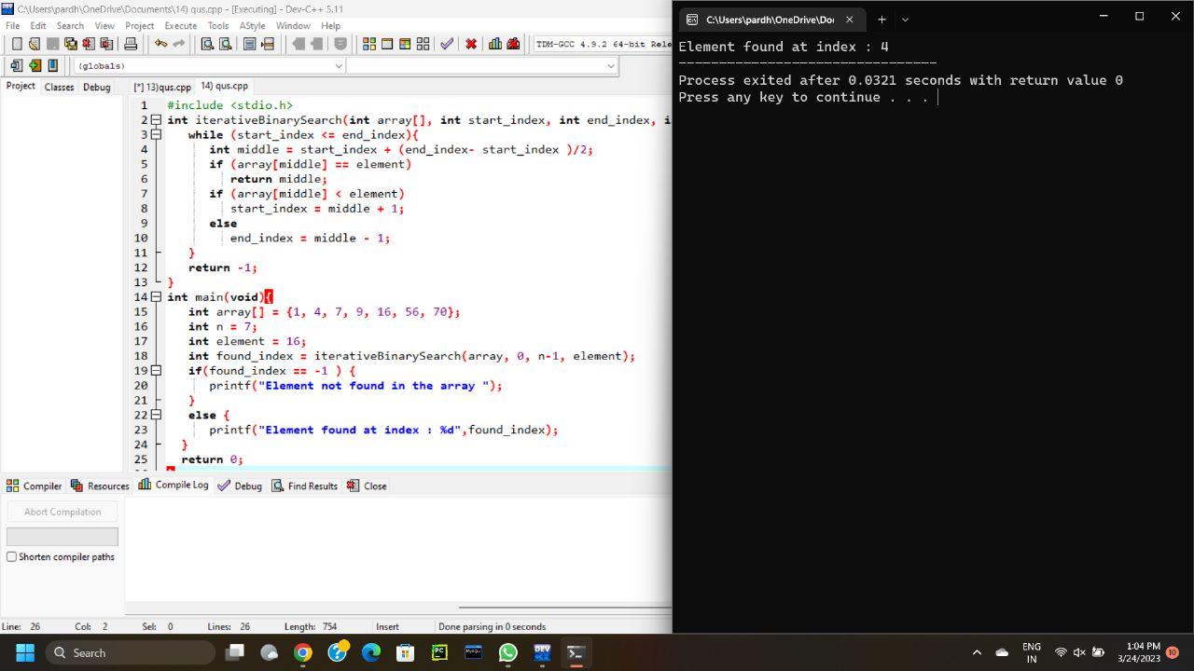

1. Program to store 3 book records in one structure / using array of structure

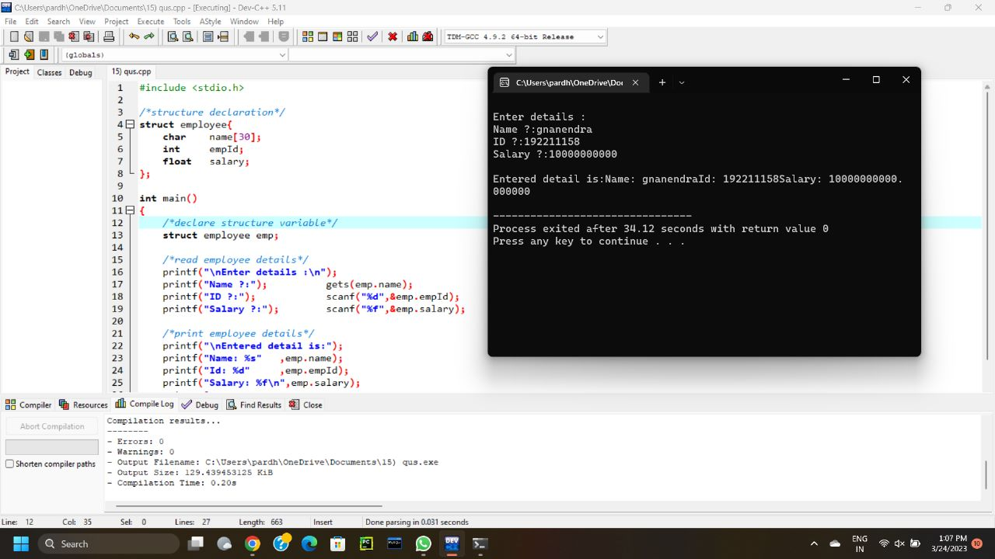

1. Find out the error and show the output

void main()

{

intarr[3][4];

inti,j,k;

printf("Enter array element");

for(i=0;i<3;i++)

{

for(j=0; j < 4; j++)

{

scanf("%d",arr[i][j]);

}

}

for(i=1; i < 3; i++)

{

for(j=0; j < 4; j++)

{

printf(“%c”,arr[i][j]);

}

}

getch();

}

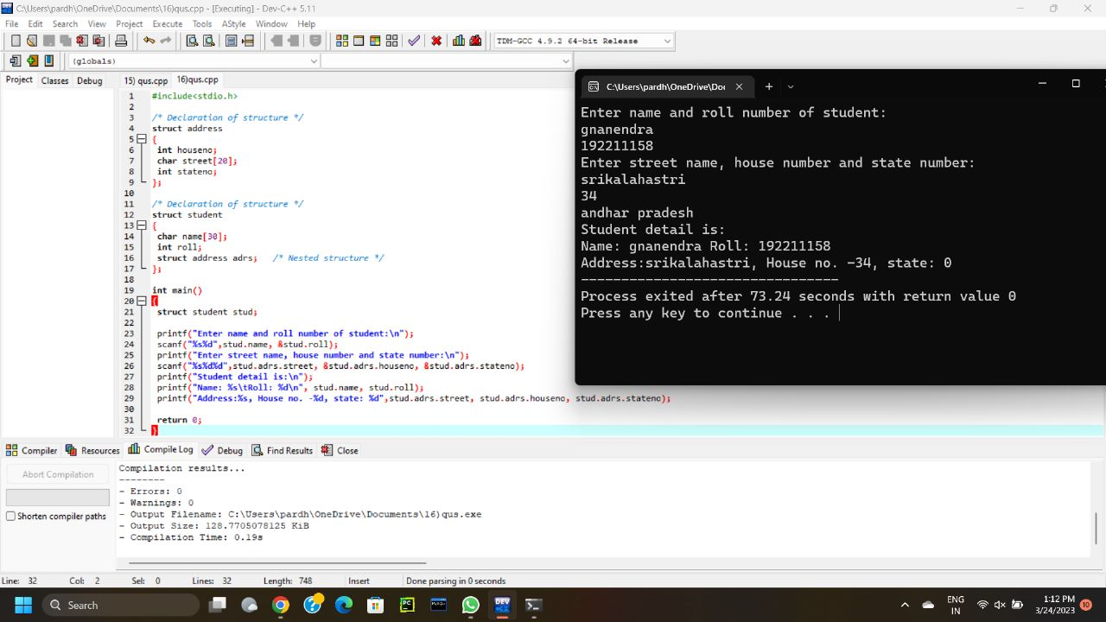

1. Find out the error and show the output

void main()

{

int a[20][20],c[20][20],i,j,r1,c1;

clrscr();

printf("\n Enter the number of rows and column of a matrix: \n");

scanf("%d",&r1,&c1);

printf("Enter the elements of matrix :");

for(i=0;i<r1;i++)

{

for(j=0;j<r1;j++)

scanf("%d",&a[i][j]);

}

printf("The elements of matrix are :");

for(i=0;i<r1;i++)

{

Printf {“\n”);

for(j=0;j<c1;j++)

printf("\t%d",&a[i][j]);

}

printf("\n Transpose Matrix is\n");

for(i=0;i<r1;i++)

{

printf("\n");

for(j=0;j<c2;j++)

{

c[i][j]=a[j][i]; /* inverse rows and column */

printf("%d\t",c[i][j]);

}

}

getch();

}

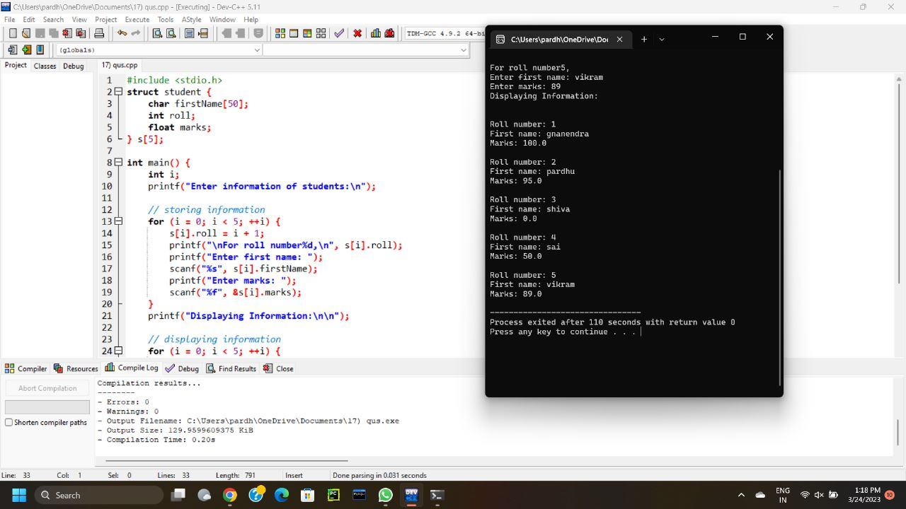

1. Find out the error and show the output

void main()

{

charstr[50];

inti,length = 0;

clrscr();

printf("\nEnter the String: ");

get(str);

for(i=0; str[i]!='\0'; i++)

{

length++;

}

printf("\nThe length of the string is %c.",count);

getche();

}



1. Find out the error and show the output

void main()

{

char str1[30],str2[30];

printf("Enter first string: ");

gets(str1);

printf("Enter second string: ");

get(str2);

if(strcmp(str1,str2)=0)

{

print("Both strings are equal");

else

printf("Strings are unequal");

}

}

